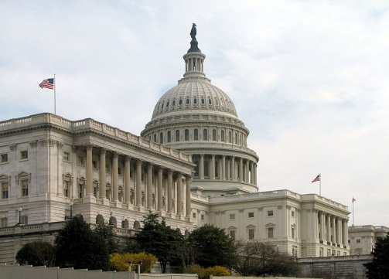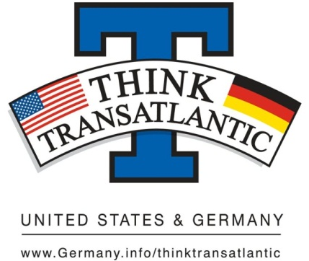

Think Transatlantic Campus Week
The Embassy of the Federal Republic of Germany has selected Washington and Jefferson College as one of 25 universities nationwide to participate in this year’s October 2012 Campus Week, with the theme "Think Transatlantic--The US and Germany in the 21st Century."

Think Transatlantic Blog Contest
Think Transatlantic – The United States and Germany

Create a blog and win!
Start your blog during the first 2 weeks of the 2012 fall semester and update it regularly. Your blog should highlight news of the German-American partnership, discuss new/current issues and their solutions, or discuss other issues and topics related to “Think Transatlantic”. The most innovative, well-founded, and successful blogs will be rewarded.

W&J 1st place-$150 Amazon Gift Card
W&J 2nd place-$100 Amazon Gift Card
W&J 3rd place-$50 Amazon Gift Card

The 1st place from W&J will be entered into the national competition. National Winners will be rewarded by the German Embassy.

You will present your blog on October 3rd (4pm-6pm) during the “Think Transatlantic Campus Week” workshop.

For questions please contact Dr. Judith Atzler: jatzler@washjeff.edu.

